Lab - Configure VLANs and Trunking.

# Topology



# Addressing Table

|  |  |  |  |  |
| --- | --- | --- | --- | --- |
| Device | Interface | IP Address | Subnet Mask | Default Gateway |
| S1 | VLAN 1 | 192.168.1.11 | 255.255.255.0 | N/A |
| S2 | VLAN 1 | 192.168.1.12 | 255.255.255.0 | N/A |
| PC-A | NIC | 192.168.10.3 | 255.255.255.0 | 192.168.10.1 |
| PC-B | NIC | 192.168.10.4 | 255.255.255.0 | 192.168.10.1 |

# Instructions

## Build the Network and Configure Basic Device Settings

In Part 1, you will set up the network topology and configure basic settings on the PC hosts and switches.

### Cable the network as shown in the topology.

Attach the devices as shown in the topology diagram, and cable as necessary.

### Configure basic settings for each switch.

* + - 1. Console into the switch and enable privileged EXEC mode.

Open configuration window

* + - 1. Enter configuration mode.
      2. Assign a device name to the switches.
      3. Configure the IP address listed in the Addressing Table for VLAN 1 on the switch.

S1(config)# **interface vlan 1**

S1(config-if)# **ip address 192.168.1.11 255.255.255.0**

S1(config-if)# **no shutdown**

Set IP address on VLAN2 on Switch 2 also.

* + - 1. Shut down all interfaces that will not be used.

S1(config)# **interface range f0/2-5, f0/7-24, g0/1-2**

S1(config-if-range)# **shutdown**

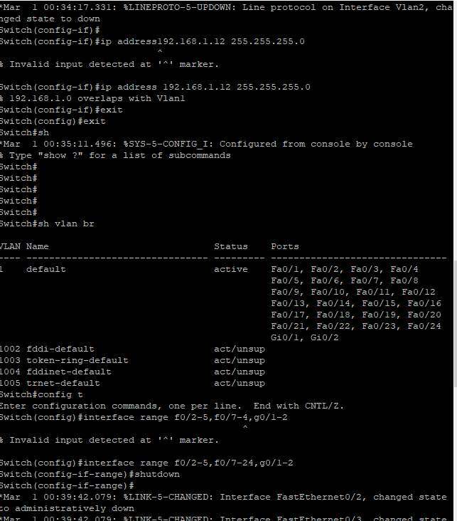

Do the same on S2.

w

### Configure PC hosts.

Refer to the Addressing Table for PC host address information.

### Test connectivity.

Verify that the PC hosts can ping one another.

**Note**: It may be necessary to disable the PCs firewall to ping between PCs.

#### Questions:

Can PC-A ping PC-B?

Ty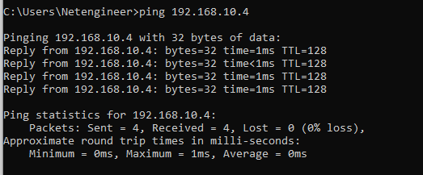pe your answers here.

Can PC-A ping S1?

T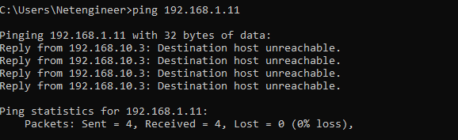ype your answers here.

Can PC-B ping S2?

Type your answers here.

Open configuration window

Can S1 ping S2?

Type your answers here.

If you answered no to any of the above questions, why were the pings unsuccessful?

Type your answers here.

Close configuration window

## Create VLANs and Assign Switch Ports

In Part 2, you will create Management, Operations, Parking_Lot, and Native VLANs on **both** switches. You will then assign the VLANs to the appropriate interface. The **show vlan** command is used to verify your configuration settings.

### Create VLANs on the switches.

Open configuration window

* + - 1. Create the VLANs on S1.

S1(config)# **vlan 10**

S1(config-vlan)# **name Operations**

S1(config-vlan)# **vlan 20**

S1(config-vlan)# **name Parking_Lot**

S1(config-vlan)# **vlan 99**

S1(config-vlan)# **name Management**

S1(config-vlan)# **vlan 1000**

S1(config-vlan)# **name Native**

S1(config-vlan)# **end**

* + - 1. Create the same VLANs on S2.
      2. Issue the **show vlan brief** command to view the list of VLANs on S1.

S1# **show vlan brief**

VLAN Name Status Ports

---- -------------------------------- --------- -------------------------------

1 default active Fa0/1, Fa0/2, Fa0/3, Fa0/4

Fa0/5, Fa0/6, Fa0/7, Fa0/8

Fa0/9, Fa0/10, Fa0/11, Fa0/12

Fa0/13, Fa0/14, Fa0/15, Fa0/16

Fa0/17, Fa0/18, Fa0/19, Fa0/20

Fa0/21, Fa0/22, Fa0/23, Fa0/24

Gi0/1, Gi0/2

10 Operations active

20 Parking_Lot active

99 Management active

1000 Native active

1002 fddi-default act/unsup

1003 token-ring-default act/unsup

1004 fddinet-default act/unsup

1005 trnet-default act/unsup

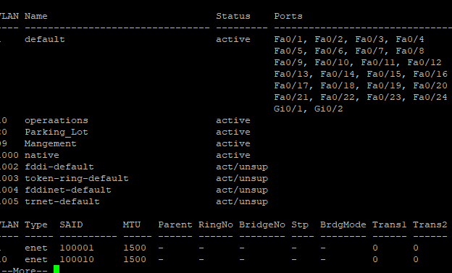

#### Questions:

What is the default VLAN?

vlan 10

What ports are assigned to the default VLAN?

f0/1 - f0/24 answers here.

### Assign VLANs to the correct switch interfaces.

* + - 1. Assign VLANs to the interfaces on S1.
         1. Assign PC-A to the Operation VLAN.

S1(config)# **interface f0/6**

S1(config-if)# **switchport mode access**

S1(config-if)# **switchport access vlan 10**

* + - * 1. Move the switch IP address VLAN 99.

S1(config)# **interface vlan 1**

S1(config-if)# **no ip address**

S1(config-if)# **interface vlan 99**

S1(config-if)# **ip address 192.168.1.11 255.255.255.0**

S1(config-if)# **end**

* + - 1. Issue the **show vlan** **brief** command and verify that the VLANs are assigned to the correct interfaces.
      2. 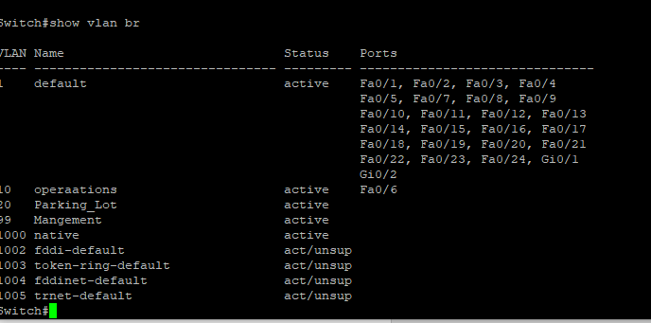
      3. Issue the **show ip interface brief** command.
      4. 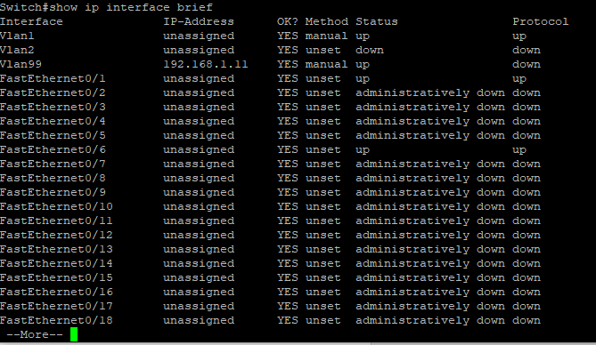

#### Question:

What is the status of VLAN 99? Explain.

Type your answers here.

* + - 1. Assign PC-B to the Operations VLAN on S2.

S2(config)# **interface f0/18**

S2(config-if)# **switchport mode access**

S2(config-if)# **switchport access vlan 10**

* + - 1. Remove the IP address for VLAN 1 on S2.

S2(config)# **interface vlan 1**

S2(config-if)# **no ip address**

* + - 1. Configure an IP address for VLAN 99 on S2 according to the Addressing Table.

S2(config-if)# **interface vlan 99**

S2(config-if)# **ip address 192.168.1.12 255.255.255.0**

* + - 1. Use the **show vlan brief** command to verify that the VLANs are assigned to the correct interfaces.

#### Questions:

Is S1 able to ping S2? Explain.

Type you answ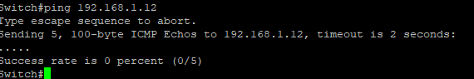ers here.

Close configuration window

Is PC-A able to ping PC-B? Explain.

Ty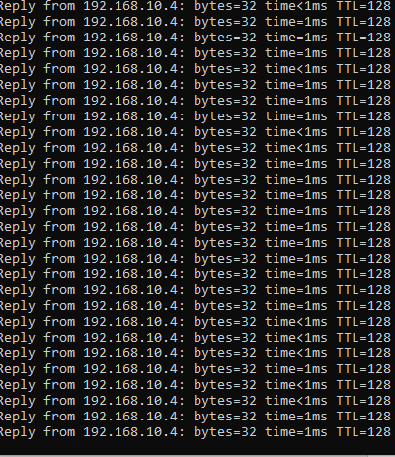pe your answers here.

## Maintain VLAN Port Assignments and the VLAN Database

In Part 3, you will change VLAN assignments to ports and remove VLANs from the VLAN database.

### Assign a VLAN to multiple interfaces.

Open configuration window

* + - 1. On S1, assign interfaces F0/11 – 24 to VLAN99.

S1(config)# **interface range f0/11-24**

S1(config-if-range)# **switchport mode access**

S1(config-if-range)# **switchport access vlan 99**

S1(config-if-range)# **end**

* + - 1. Issue the **show vlan brief** command to verify VLAN assignments.

S1# **show vlan brief**

VLAN Name Status Ports

---- -------------------------------- --------- -------------------------------

1 default active Fa0/1, Fa0/2, Fa0/3, Fa0/4

Fa0/5, Fa0/7, Fa0/8, Fa0/9

Fa0/10, Gi0/1, Gi0/2

10 Operations active Fa0/6

20 Parking_Lot active

99 Management active Fa0/11, Fa0/12, Fa0/13, Fa0/14

Fa0/15, Fa0/16, Fa0/17, Fa0/18

Fa0/19, Fa0/20, Fa0/21, Fa0/22

Fa0/23, Fa0/24

1000 Native active

* + - 1. Reassign F0/11 and F0/21 to VLAN 10.

S1(config)# **interface range f0/11, f0/21**

S1(config-if-range)# **switchport access vlan 10**

S1(config-if-range)# **end**

* + - 1. Verify that VLAN assignments are correct.

S1# **show vlan brief**

### Remove a VLAN assignment from an interface.

* + - 1. Use the **no** **switchport access vlan** command to remove the VLAN 99 assignment to F0/24.

S1(config)# **interface f0/24**

S1(config-if)# **no switchport access vlan**

S1(config-if)# **end**

* + - 1. Verify that the VLAN change was made.

#### Question:

Which VLAN is F0/24 now associated with?

Type your answers here.

### Remove a VLAN ID from the VLAN database.

* + - 1. Add VLAN 30 to interface F0/24 without issuing the global VLAN command.

S1(config)# **interface f0/24**

S1(config-if)# **switchport access vlan 30**

% Access VLAN does not exist. Creating vlan 30

**Note**: Current switch technology no longer requires that the **vlan** command be issued to add a VLAN to the database. By assigning an unknown VLAN to a port, the VLAN will be created and added to the VLAN database.

* + - 1. Verify that the new VLAN is displayed in the VLAN table.

S1# **show vlan brief**

#### Question:

What is the default name of VLAN 30?

Type your answers here.

* + - 1. Use the **no vlan 30** command to remove VLAN 30 from the VLAN database.

S1(config)# **no vlan 30**

S1(config)# **end**

* + - 1. Issue the **show vlan brief** command. F0/24 was assigned to VLAN 30.

#### Question:

After deleting VLAN 30 from the VLAN database, what VLAN is port F0/24 assigned to? What happens to the traffic destined to the host attached to F0/24?

Type your answers here.

* + - 1. Issue the **no switchport access vlan** command on interface F0/24.

S1(config)# **interface f0/24**

S1(config-if)# **no switchport access vlan**

S1(config-if)# **end**

* + - 1. Issue the **show vlan brief** command to determine the VLAN assignment for F0/24.

#### Questions:

To which VLAN is F0/24 assigned?

Type your answers here.

The default VLAN, VLAN 1

S1# **show vlan brief**

VLAN Name Status Ports

---- -------------------------------- --------- -------------------------------

1 default active Fa0/1, Fa0/2, Fa0/3, Fa0/4

Fa0/5, Fa0/7, Fa0/8, Fa0/9

Fa0/10, Fa0/24, Gi0/1, Gi0/2

10 Operations active Fa0/6, Fa0/11, Fa0/21

20 Parking_Lot active

99 Management active Fa0/12, Fa0/13, Fa0/14, Fa0/15

Fa0/16, Fa0/17, Fa0/18, Fa0/19

Fa0/20, Fa0/22, Fa0/23

1000 Native active

Why should you reassign a port to another VLAN before removing the VLAN from the VLAN database?

ype your answers here.

Close configuration window

## Configure an 802.1Q Trunk Between the Switches

In Part 4, you will configure interface F0/1 to use the Dynamic Trunking Protocol (DTP) to allow it to negotiate the trunk mode. After this has been accomplished and verified, you will disable DTP on interface F0/1 and manually configure it as a trunk.

### Use DTP to initiate trunking on F0/1.

The default DTP mode of a 2960 switch port is dynamic auto. This allows the interface to convert the link to a trunk if the neighboring interface is set to trunk or dynamic desirable mode.

Open configuration window

* + - 1. Set F0/1 on S1 to negotiate trunk mode.

S1(config)# **interface f0/1**

S1(config-if)# **switchport mode dynamic desirable**

Sep 19 02:51:47.257: %LINEPROTO-5-UPDOWN: Line protocol on Interface FastEthernet0/1, changed state to up

Sep 19 02:51:47.291: %LINEPROTO-5-UPDOWN: Line protocol on Interface Vlan99, changed state to up

You should also receive link status messages on S2.

S2#

Sep 19 02:42:19.424: %LINK-3-UPDOWN: Interface FastEthernet0/1, changed state to up

Sep 19 02:42:21.454: %LINEPROTO-5-UPDOWN: Line protocol on Interface Vlan99, changed state to up

Sep 19 02:42:22.419: %LINEPROTO-5-UPDOWN: Line protocol on Interface FastEthernet0/1, changed state to up

* + - 1. Issue the **show vlan brief** command on S1 and S2. Interface F0/1 is no longer assigned to VLAN 1. Trunked interfaces are not listed in the VLAN table.

S1# **show vlan brief**

VLAN Name Status Ports

---- -------------------------------- --------- -------------------------------

1 default active Fa0/2, Fa0/3, Fa0/4, Fa0/5

Fa0/7, Fa0/8, Fa0/9, Fa0/10

Fa0/24, Gi0/1, Gi0/2

10 Operations active Fa0/6, Fa0/11, Fa0/21

20 Parking_Lot active

99 Management active Fa0/12, Fa0/13, Fa0/14, Fa0/15

Fa0/16, Fa0/17, Fa0/18, Fa0/19

Fa0/20, Fa0/22, Fa0/23

1000 Native active

1002 fddi-default act/unsup

1003 token-ring-default act/unsup

1004 fddinet-default act/unsup

1005 trnet-default act/unsup

* + - 1. Issue the **show interfaces trunk** command to view trunked interfaces. Notice that the mode on S1 is set to desirable, and the mode on S2 is set to auto.

S1# **show interfaces trunk**

Port Mode Encapsulation Status Native vlan

Fa0/1 desirable 802.1q trunking 1

Port Vlans allowed on trunk

Fa0/1 1-4094

Port Vlans allowed and active in management domain

Fa0/1 1,10,20,99,1000

Port Vlans in spanning tree forwarding state and not pruned

Fa0/1 1,10,20,99,1000

S2# **show interfaces trunk**

Port Mode Encapsulation Status Native vlan

Fa0/1 auto 802.1q trunking 1

Port Vlans allowed on trunk

Fa0/1 1-4094

Port Vlans allowed and active in management domain

Fa0/1 1,10,20,99,1000

Port Vlans in spanning tree forwarding state and not pruned

Fa0/1 1,10,20,99,1000

Close configuration window

* + - 1. Verify that VLAN traffic is traveling over trunk interface F0/1.

#### Questions:

Can S1 ping S2?

Type your yes answers here.

Can PC-A ping PC-B?

Type your ayesnswers here.

Can PC-A ping S1?

Type youyes r answers here.

Can PC-B ping S2?

Type yoyes ur answers here.

If you answered no to any of the above questions, explain below.

Type your answers here.

### Manually configure trunk interface F0/1.

The **switchport mode trunk** command is used to manually configure a port as a trunk. This command should be issued on both ends of the link.

* + - 1. Change the switchport mode on interface F0/1 to force trunking. Make sure to do this on both switches.

Open configuration window

S1(config)# **interface f0/1**

S1(config-if)# **switchport mode trunk**

S2(config)# **interface f0/1**

S2(config-if)# **switchport mode trunk**

* + - 1. Issue the **show interfaces trunk** command to view the trunk mode. Notice that the mode changed from **desirable** to **on**.

S2# **show interfaces trunk**

Port Mode Encapsulation Status Native vlan

Fa0/1 on 802.1q trunking 1

Port Vlans allowed on trunk

Fa0/1 1-4094

Port Vlans allowed and active in management domain

Fa0/1 1,10,20,99,1000

Port Vlans in spanning tree forwarding state and not pruned

Fa0/1 1,10,20,99,1000

* + - 1. Modify the trunk configuration on both switches by changing the native VLAN from VLAN 1 to VLAN 1000.

S1(config)# **interface f0/1**

S1(config-if)# **switchport trunk native vlan 1000**

S2(config)# **interface f0/1**

S2(config-if)# **switchport trunk native vlan 1000**

* + - 1. Issue the show interfaces trunk command to view the trunk. Notice the Native VLAN information is updated.

S2# **show interfaces trunk**

Port Mode Encapsulation Status Native vlan

Fa0/1 on 802.1q trunking 1000

Port Vlans allowed on trunk

Fa0/1 1-4094

Port Vlans allowed and active in management domain

Fa0/1 1,10,20,99,1000

Port Vlans in spanning tree forwarding state and not pruned

Fa0/1 1,10,20,99,1000

#### Questions:

Why might you want to manually configure an interface to trunk mode instead of using DTP?

Type your answers here.

Why might you want to change the native VLAN on a trunk?

T

Close configuration window

## Delete the VLAN Database

In Part 5, you will delete the VLAN Database from the switch. It is necessary to do this when initializing a switch back to its default settings.

### Determine if the VLAN database exists.

Open configuration window

Issue the **show flash** command to determine if a **vlan.dat** file exists in flash.

S1# **show flash:**

Directory of flash:/

2 -rwx 59416 Mar 1 1993 01:20:12 +00:00 multiple-fs

3 -rwx 15186645 Mar 1 1993 00:19:23 +00:00 c2960-lanbasek9-mz.152-4.E8.bin

5 -rwx 796 Sep 19 2019 02:48:04 +00:00 vlan.dat

61028352 bytes total (33762304 bytes free)

**Note**: If there is a **vlan.dat** file located in flash, then the VLAN database does not contain its default settings.

### Delete the VLAN database.

* + - 1. Issue the **delete vlan.dat** command to delete the vlan.dat file from flash and reset the VLAN database back to its default settings. You will be prompted twice to confirm that you want to delete the vlan.dat file. Press Enter both times.

S1# **delete vlan.dat**

Delete filename [vlan.dat]?

Delete flash:/vlan.dat? [confirm]

* + - 1. Issue the **show flash** command to verify that the vlan.dat file has been deleted.

S1# **show flash:**

Directory of flash:/

2 -rwx 59416 Mar 1 1993 01:20:12 +00:00 multiple-fs

3 -rwx 15186645 Mar 1 1993 00:19:23 +00:00 c2960-lanbasek9-mz.152-4.E8.bin

61028352 bytes total (33763840 bytes free)

#### Question:

To initialize a switch back to its default settings, what other commands are needed?

Type your answers here.

Close configuration window